EXPT NO: 7 | GENERATE SYNTHETIC IMAGES USING A GENERATIVE ADVERSARIAL NETWORK (GAN)
DATE: 05.10.2026

PRE-LAB QUESTIONS (PROVIDE BRIEF ANSWERS TO THE FOLLOWING QUESTIONS)

- What is a Generative Adversarial Network (GAN)?
A Generative Adversarial Network (GAN) is a type of deep learning model used to generate new data that resembles real data. It consists of two neural networks called the Generator and the Discriminator, which are trained together in a competitive process. The Generator creates synthetic samples, such as images, while the Discriminator tries to distinguish generated samples from real ones. Through repeated training, the Generator learns the patterns and features of the training dataset and produces increasingly realistic synthetic images.

- What are the roles of the Generator and Discriminator in a GAN?
The Generator and Discriminator perform two different but complementary roles in a GAN. The Generator receives a random noise vector as input and transforms it into a synthetic image that resembles the training data. The Discriminator receives both real images and generated images and predicts whether each image is real or fake. During training, the Generator attempts to fool the Discriminator, while the Discriminator learns to identify generated images correctly. Their competition gradually improves the quality of the generated images.

- Why are GANs used for synthetic image generation?
GANs are used for synthetic image generation because they can learn complex visual patterns from existing image datasets and use that knowledge to create new images. They can generate realistic handwritten digits, human faces, objects, and other visual content. Synthetic images can help increase the amount of training data available for machine learning applications and support research in computer vision. GANs are also useful for image enhancement, style transfer, and creative design. Their ability to generate new samples makes them valuable in many artificial intelligence applications.

- What is the difference between real images and synthetic images?
Real images are obtained from actual photographs, scanned documents, cameras, or other genuine image sources. They represent objects, people, or scenes captured from the real world. Synthetic images are artificially generated using computer algorithms or models such as GANs. They are created by learning patterns from existing data rather than directly capturing a real scene. Although synthetic images may appear realistic, they are generated by a model and may contain visual errors or unrealistic details. Both types of images can be useful for training and testing machine learning systems.

- Explain the concept of adversarial training in GANs.
Adversarial training is the learning process in which the Generator and Discriminator compete against each other to improve their performance. The Generator produces synthetic images and attempts to make them appear real, while the Discriminator learns to identify whether an image comes from the original dataset or the Generator. Their parameters are updated repeatedly using a training process based on their respective losses. As the Discriminator becomes better at identifying fake images, the Generator learns to produce more realistic samples. This competition continues until the generated images become sufficiently convincing, although perfect results are not guaranteed.

AIM
To implement a Generative Adversarial Network (GAN) for generating synthetic images by training a Generator and Discriminator on an image dataset and evaluating the quality of the generated images.

SOFTWARE REQUIREMENTS
- Python
- TensorFlow / Keras
- Google Colab
- GitHub
- NumPy
- Matplotlib
- Pandas

OBJECTIVES
Students will be able to:
- Understand the architecture and working of Generative Adversarial Networks.
- Understand the roles of the Generator and Discriminator.
- Prepare and preprocess an image dataset for GAN training.
- Build a Generator network for synthetic image generation.
- Build a Discriminator network for distinguishing real and generated images.
- Train a GAN using adversarial learning.
- Generate synthetic images using the trained Generator.
- Visualize and analyze the quality of generated images.

PROCEDURE
PART A: DATASET PREPARATION AND IMAGE PREPROCESSING
Perform the following tasks:
- Load an image dataset such as the MNIST handwritten digit dataset.
- Explore the dataset and examine sample images.
- Check the number of images and image dimensions.
- Display sample images from the dataset.
- Normalize the pixel values to the range [-1, 1].
- Reshape the images into the required input format.
- Prepare the dataset for batch-wise training.
- Create a data pipeline using appropriate TensorFlow/Keras utilities.

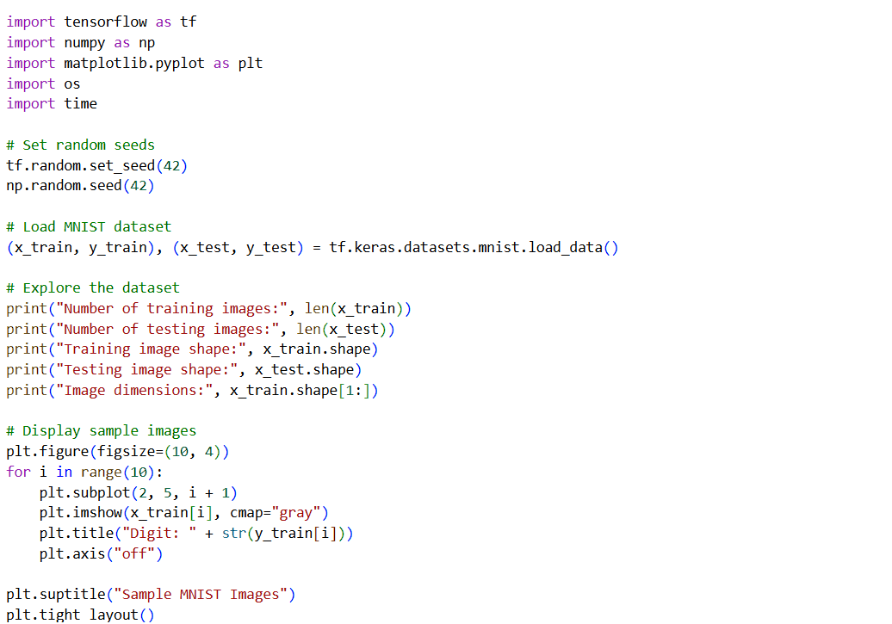
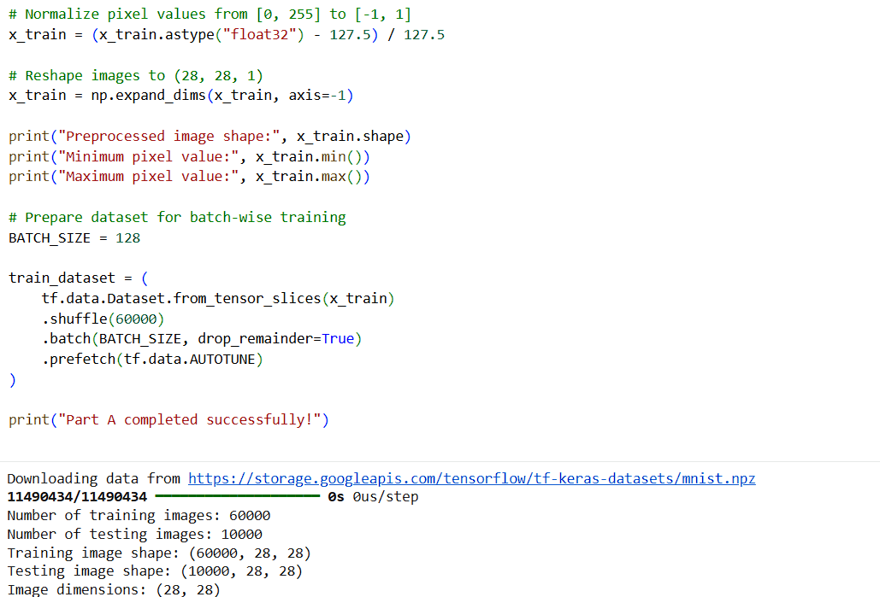
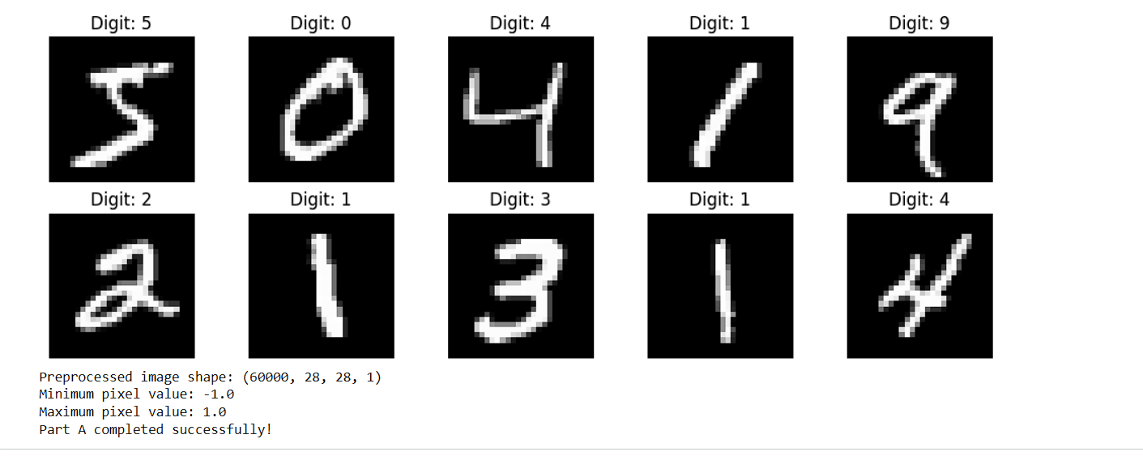

PART B: IMPLEMENTING THE GENERATOR
Perform the following tasks:
- Define a random noise vector as the input to the Generator.
- Create the Generator using appropriate neural network layers.
- Use Dense and convolutional/transposed convolutional layers to generate images.
- Apply appropriate activation functions.
- Generate an image from a random noise vector.
- Display the generated image before GAN training.
- Display the Generator model architecture and summary.
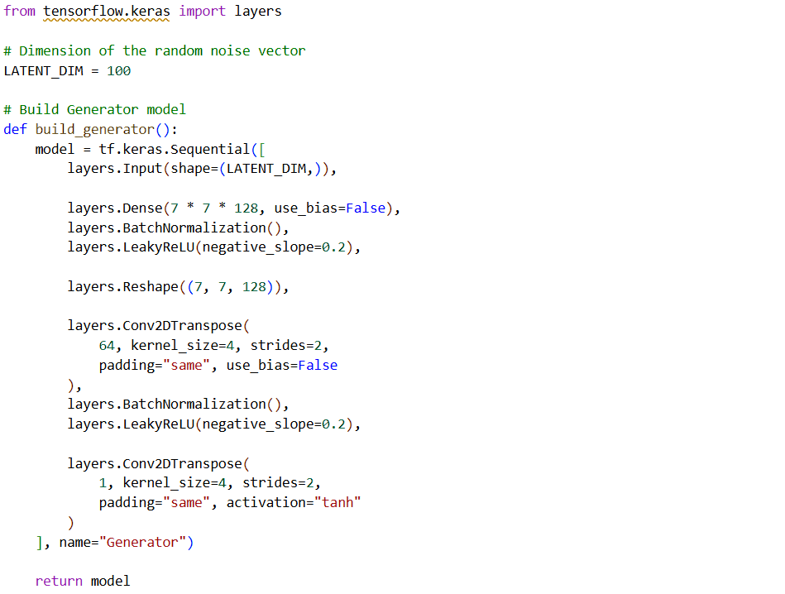
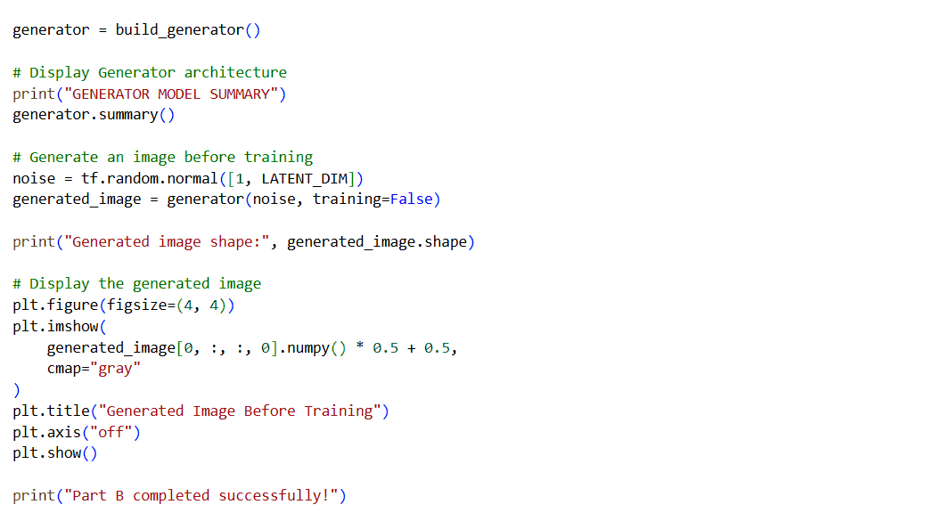
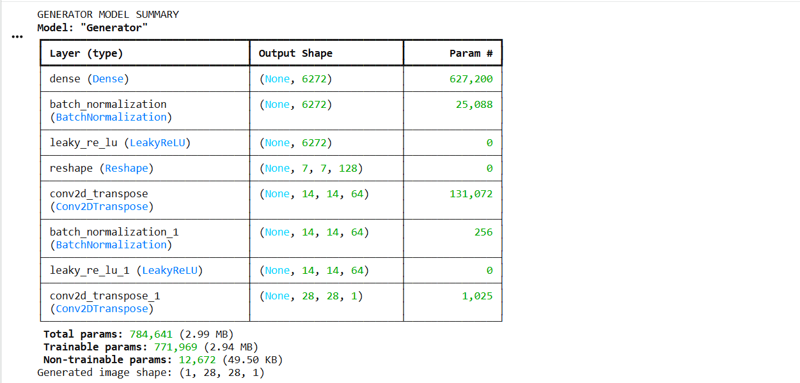
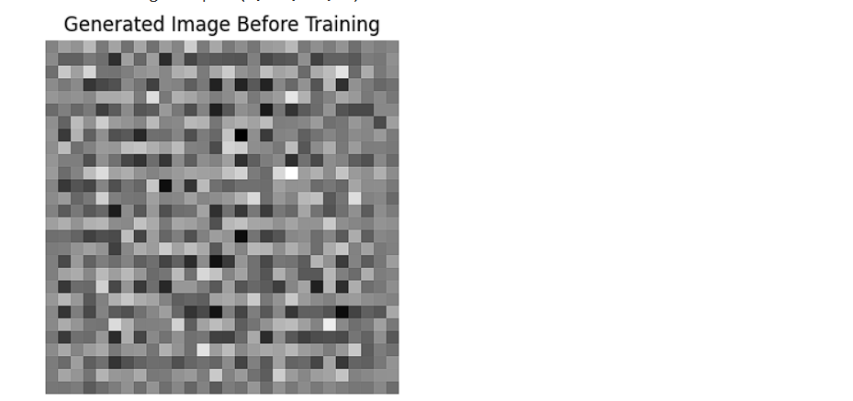

PART C: IMPLEMENTING THE DISCRIMINATOR AND GAN MODEL
Perform the following tasks:
- Create a Discriminator network to classify images as real or generated.
- Add convolutional layers to extract image features.
- Add appropriate activation functions.
- Add a final output layer for binary classification.
- Compile the Discriminator using:
  - Appropriate optimizer
  - Binary cross-entropy loss
- Combine the Generator and Discriminator to form the GAN.
- Display the Generator and Discriminator model summaries.

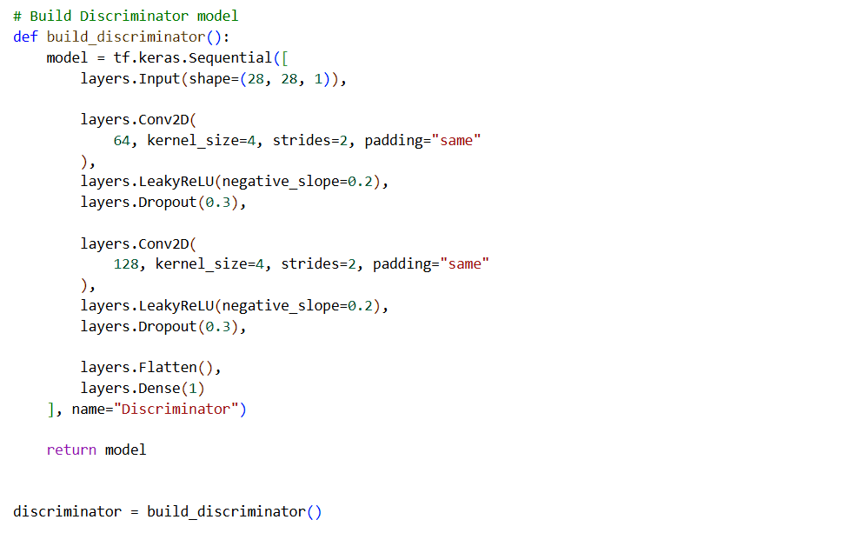
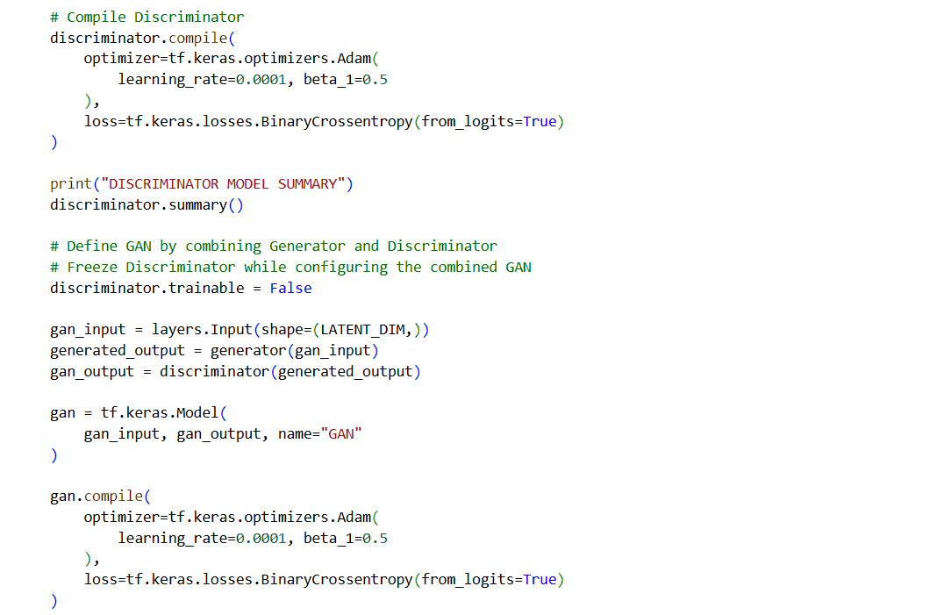
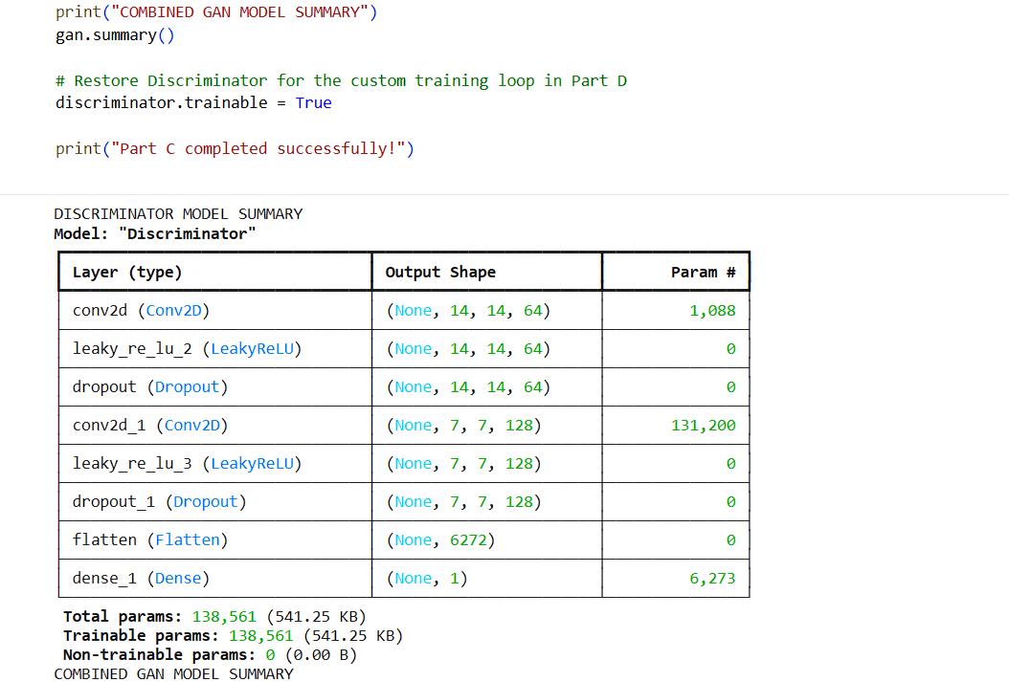
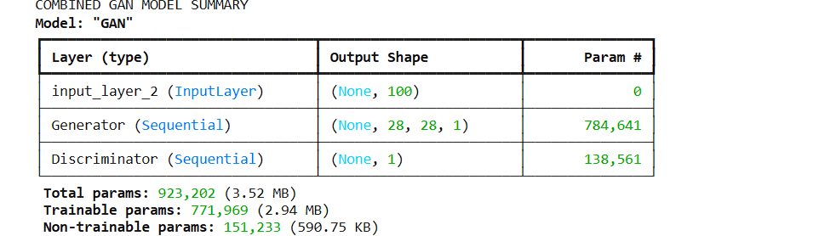

PART D: GAN TRAINING AND SYNTHETIC IMAGE GENERATION
Perform the following tasks:
- Initialize the Generator with random noise.
- Train the Discriminator using:
  - Real images from the dataset.
  - Synthetic images generated by the Generator.
- Train the Generator through the combined GAN model.
- Record:
  - Generator loss
  - Discriminator loss
- Repeat the training process for the specified number of epochs.
- Generate synthetic images at regular training intervals.
- Visualize generated images at different stages of training.
- Compare the generated images with real images.
- Analyze the quality and diversity of the generated images.
- Save the final generated images.

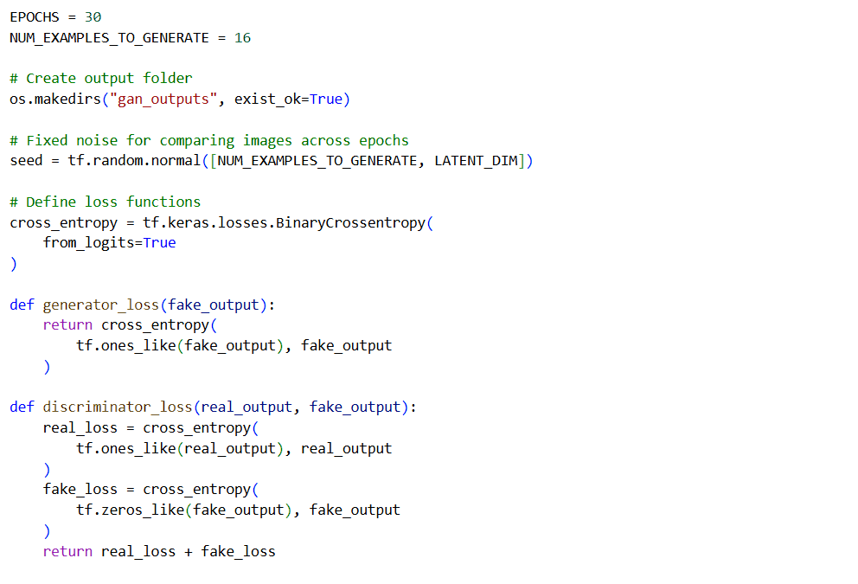
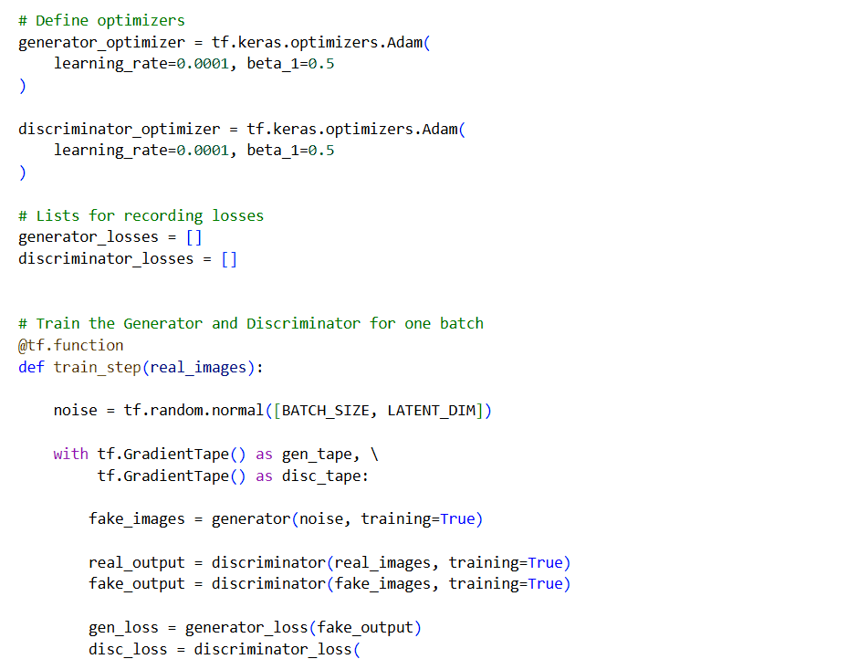
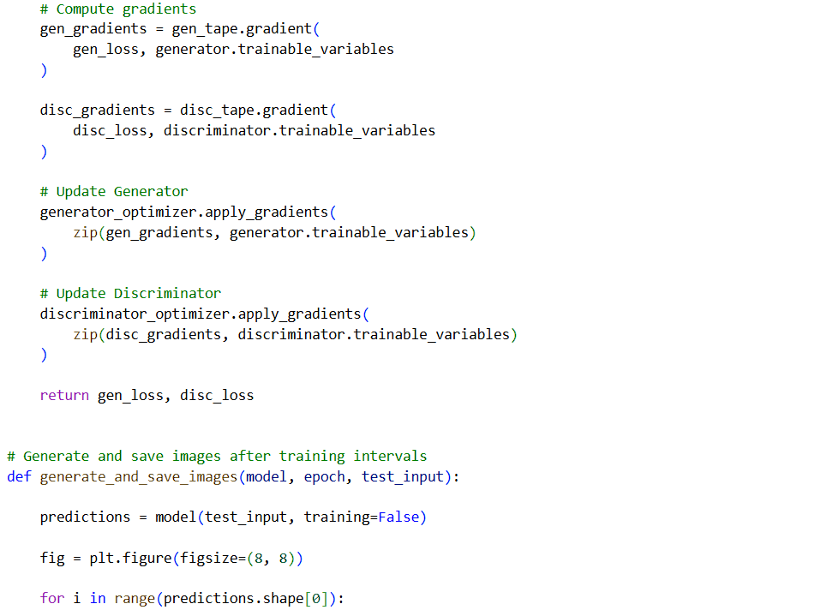
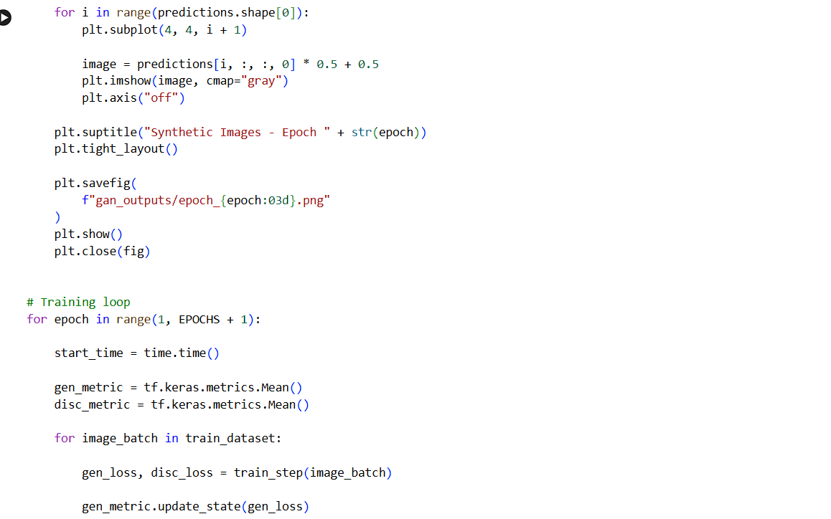
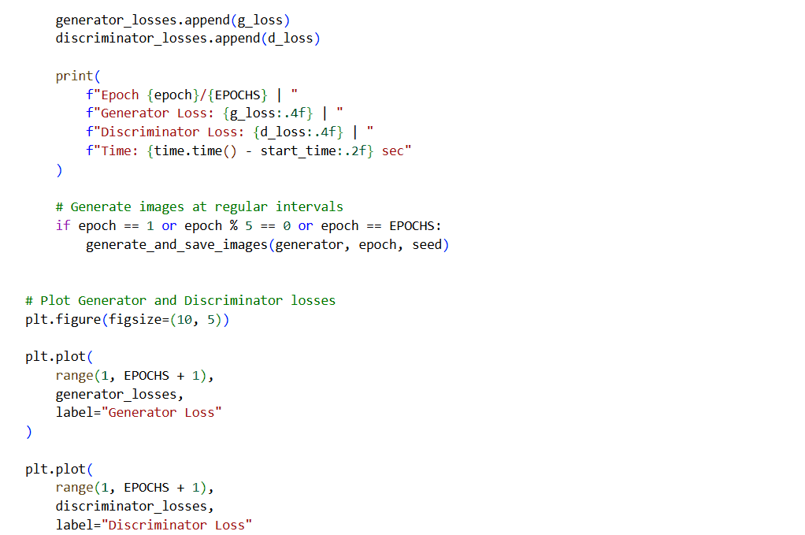
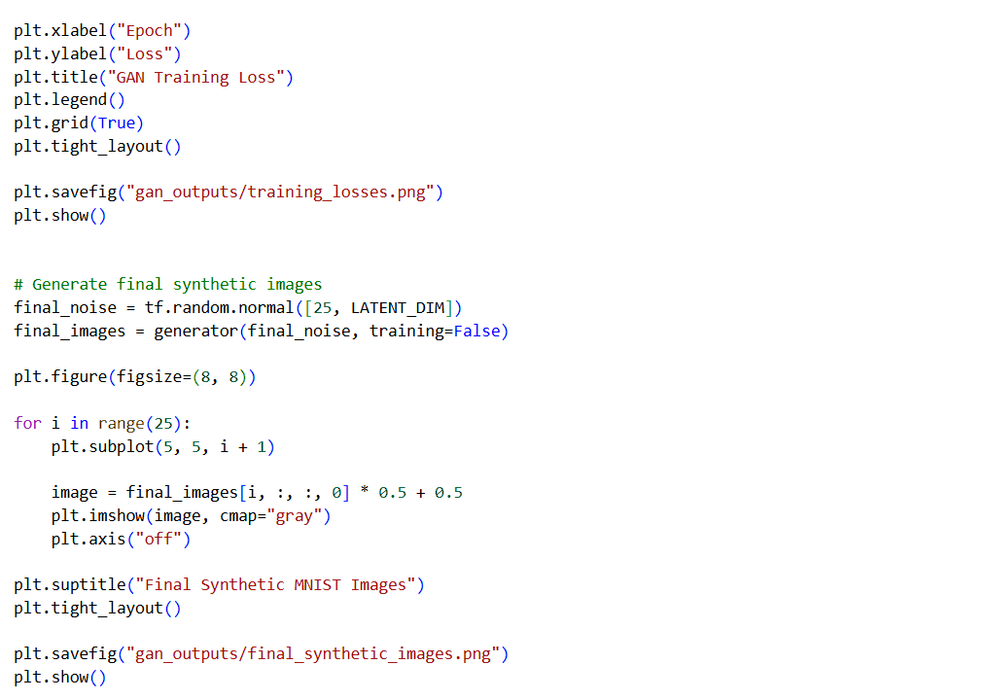
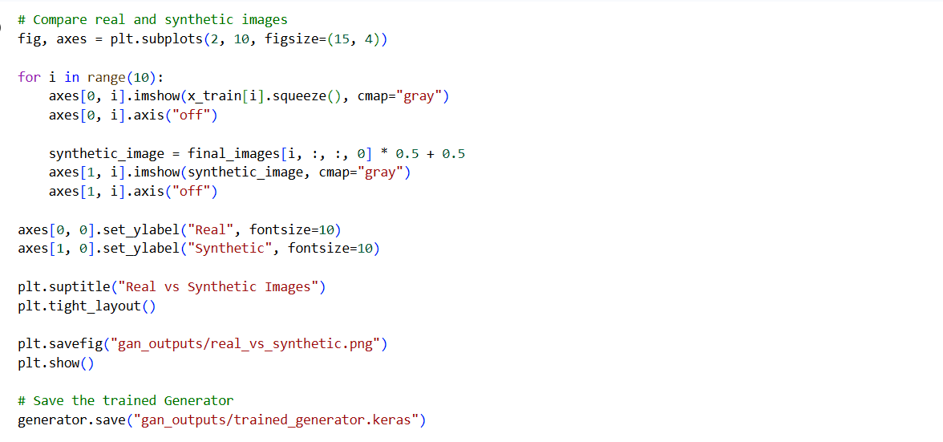
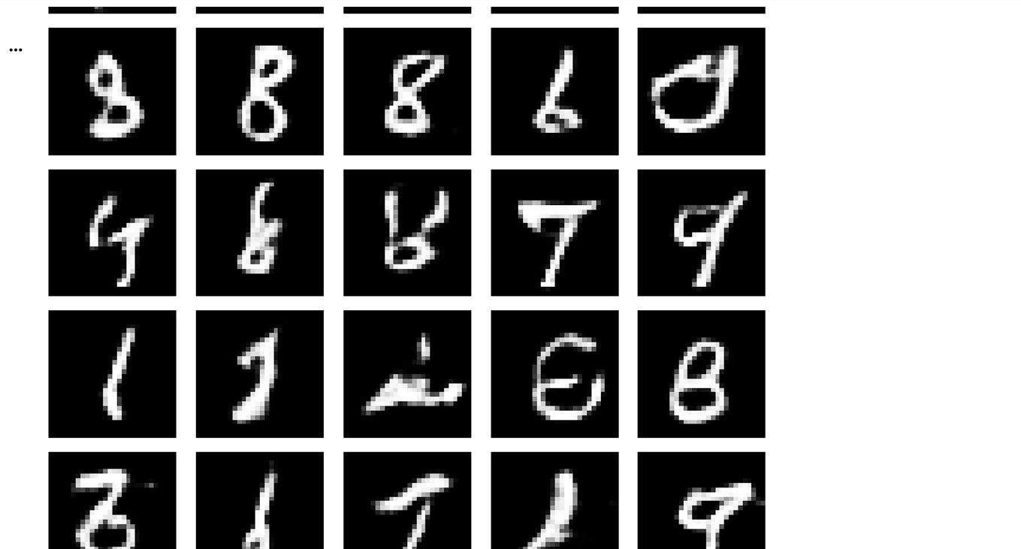
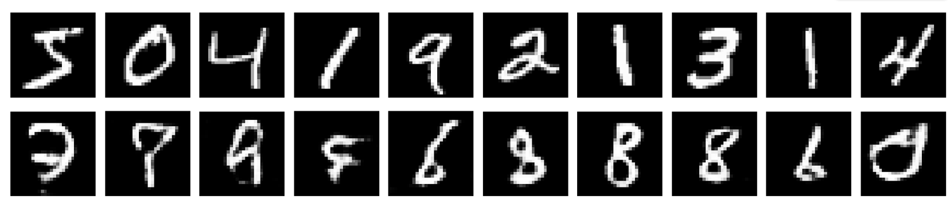

EXPECTED OUTCOME
Students will understand the architecture and working of Generative Adversarial Networks (GANs) and the interaction between the Generator and Discriminator during adversarial training. Students will learn to preprocess image data, build and train GAN models, and generate synthetic images. They will evaluate the generated images by visually comparing them with real images and analyzing the improvement in image quality during training.

POST-LAB QUESTIONS (PROVIDE BRIEF ANSWERS TO THE FOLLOWING QUESTIONS)

- What is the role of the Generator in a GAN?
The Generator is one of the two main neural networks in a Generative Adversarial Network. Its primary role is to create synthetic images that resemble images in the training dataset. It takes a random noise vector as input and processes it through neural network layers to generate an image. During training, the Generator receives feedback through the combined GAN model and adjusts its parameters to improve image quality. Its main objective is to produce realistic images that can fool the Discriminator into classifying them as real.

- What is the role of the Discriminator in a GAN?
The Discriminator is a neural network responsible for distinguishing real images from synthetic images generated by the Generator. It receives images from both sources and produces an output indicating whether an image is likely to be real or fake. During training, it learns the features and patterns that help it classify the images correctly. The Discriminator's parameters are updated to reduce classification errors. Its feedback also helps the Generator improve the realism of its outputs. Therefore, the Discriminator plays an important role in the adversarial learning process.

- Why is random noise used as input to the Generator?
Random noise is used as input to the Generator because it provides a starting point for creating different synthetic images. The Generator transforms a random noise vector into an image by learning patterns from the training dataset. Different noise vectors can produce different outputs, allowing the model to generate a variety of images rather than reproducing only one fixed image. Random noise also helps the Generator explore different possibilities in the learned data distribution. For example, in an MNIST experiment, different noise vectors may generate different handwritten digits after sufficient training.

- What happens when the Discriminator becomes too strong during GAN training?
When the Discriminator becomes too strong, it can identify generated images as fake with very high confidence. As a result, the Generator may receive weak or unhelpful learning signals, making it difficult to improve its generated images. This can slow down training or cause the GAN to become unstable. The Generator may struggle to produce realistic outputs because the Discriminator rejects most of its attempts. To address this problem, the training process must maintain a reasonable balance between both networks, using suitable learning rates, training schedules, and model configurations.

- What is meant by mode collapse in GANs?
Mode collapse is a problem in GAN training in which the Generator produces only a limited variety of images, even though the training dataset contains many different patterns or categories. For example, when trained on the MNIST dataset, a Generator affected by mode collapse might repeatedly produce images resembling the digit 7 while rarely generating other digits. Although some generated images may look realistic, the overall diversity is poor. Mode collapse reduces the usefulness of synthetic data. Techniques such as adjusting training parameters and using improved GAN architectures can help reduce this problem.

- How does the Generator improve the quality of generated images during training?
The Generator improves the quality of generated images by repeatedly updating its parameters based on feedback from the Discriminator through the GAN training process. Initially, its outputs may appear random, unclear, or unlike the real images in the dataset. As training continues, the Generator learns useful patterns, shapes, textures, and other visual features from the training data. It then uses these learned features to create more realistic images. Monitoring generated samples at different epochs helps evaluate progress. However, improvement depends on suitable training settings, sufficient data, and a stable balance between both networks.

- Mention one real-world application of GANs.
One important real-world application of GANs is image enhancement and restoration. GANs can be trained to improve the visual quality of low-resolution or degraded images by generating sharper details and more realistic textures. For example, a GAN-based system can help convert a low-resolution image into a higher-resolution version that appears clearer. Similar techniques can support the restoration of damaged photographs and the improvement of certain medical or scientific images. However, generated details may not always be accurate, so the outputs should be carefully evaluated, especially in applications where image correctness is important.

- What is the difference between GAN training and conventional neural network training?
GAN training differs from conventional neural network training because it involves two neural networks that compete with each other. In conventional supervised learning, a model typically learns by comparing its predictions with known target labels and minimizing a loss function. In GAN training, the Generator attempts to create realistic synthetic data, while the Discriminator tries to distinguish real data from generated data. Both networks are updated through an adversarial process. This makes GAN training more complex and potentially unstable than ordinary supervised training, but it enables the generation of new data without requiring a target image for every generated sample.

SUGGESTIONS FOR DATASETS
- MNIST Handwritten Digits – https://www.tensorflow.org/datasets/catalog/mnist
- Fashion-MNIST – https://www.tensorflow.org/datasets/catalog/fashion_mnist
- CIFAR-10 – https://www.tensorflow.org/datasets/catalog/cifar10
- CelebA – https://www.tensorflow.org/datasets/catalog/celeb_a
- Oxford-IIIT Pet Dataset – https://www.tensorflow.org/datasets/catalog/oxford_iiit_pet

ASSESSMENT
Description | Max Marks | Marks Awarded
Pre Lab Exercise | 5
In Lab Exercise | 10
Post Lab Exercise | 5
Viva | 10
Total | 30
Faculty Signature

